**SCENARIO 1:**

BEGIN

FOR cust IN (SELECT customer_id FROM customers WHERE age > 60) LOOP

UPDATE loans

SET interest_rate = interest_rate - 1

WHERE customer_id = cust.customer_id;

END LOOP;

COMMIT;

END;

/

**OUTPUT:**

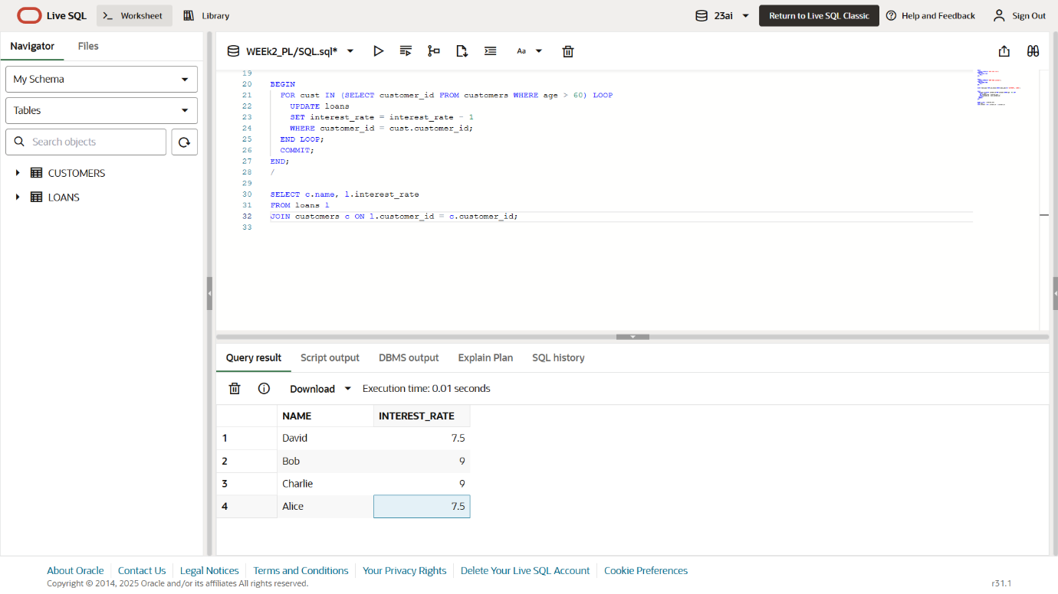

**SCENARIO 2:**

BEGIN

FOR cust IN (SELECT customer_id, balance FROM customers) LOOP

IF cust.balance > 10000 THEN

UPDATE customers

SET isvip = 'TRUE'

WHERE customer_id = cust.customer_id;

END IF;

END LOOP;

COMMIT;

END;

/

**OUTPUT:**

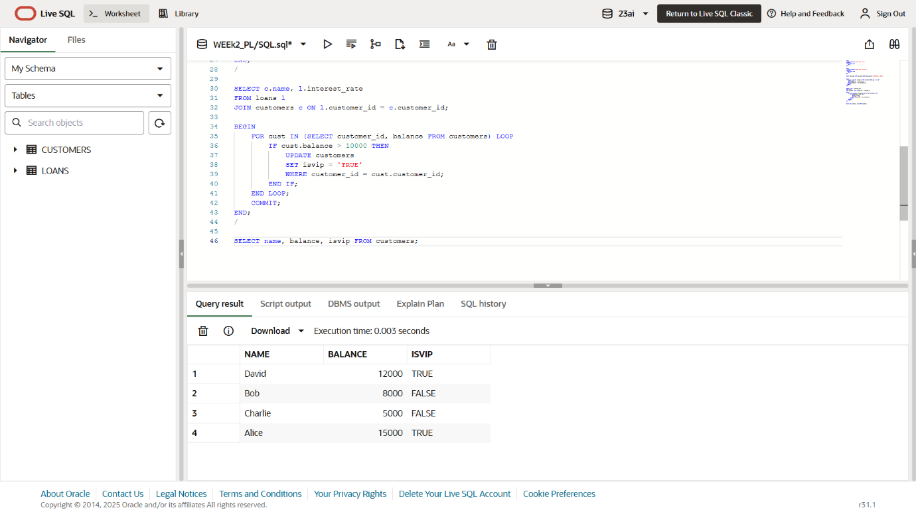

**SCENARIO 3:**

BEGIN

FOR loan_rec IN (

SELECT l.loan_id, c.name, l.due_date

FROM loans l

JOIN customers c ON l.customer_id = c.customer_id

WHERE l.due_date <= SYSDATE + 30

) LOOP

DBMS_OUTPUT.PUT_LINE('Reminder: Dear ' || loan_rec.name ||

', your loan (ID: ' || loan_rec.loan_id ||

') is due on ' || TO_CHAR(loan_rec.due_date, 'DD-Mon-YYYY'));

END LOOP;

END;

/

**OUTPUT:**

